**GUGULETHU BEATRICE SEBELE**

**PERSONAL DETAILS**

Contact details: 0774943668

ID Number: 56-2011156Q56

Address: 15 Red Robin Close Burnside Bulawayo

Languages: English, Ndebele, Khalanga

EMAIL ADDRESS: [sebelegugulethu223@gmail.com](mailto:sebelegugulethu223@gmail.com)

**Objective:** Highly motivated and detail- oriented Computer Science student seeking an internship opportunity to apply theoretical knowledge in a practical setting, gain hands-on experience with industry-standard technologies and contribute to innovative projects.

**Skills**

* Time management
* Teamwork
* Effective communication skills
* Critical thinking
* Leadership
* Windows Operating System
* Networking: firewalls, switches, TCP/IP
* HTML and CSS
* PHP , JavaScript and React js
* Java , python and C programming
* Software project management
* Cybersecurity principles, threat analysis and threat detection
* Project management
* MySQL database

**Certifications**

* CISCO Networking Basics
* CISCO Introduction to Cybersecurity
* CISCO to Introduction to Data Science.
* Computer operations and packages (2018 )

**ACADEMIC QUALIFICATIONS**

**ORDINARY LEVEL**: 2016 – 2019 USHER HIGH SCHOOL

11 O Levels including Mathematics (A), English (B), Physics (B), Chemistry (B), Biology (B). In total 4As, 6 Bs and 1 Cs

**ADVANCED LEVEL:** 2020 – 2021 USHER HIGH SCHOOL

3 A Level passes in Physics, Chemistry and Pure mathematics

**CURRENT STUDIES**

Bachelor of Science Honours Degree in Computer Science (National University of Science and Technology) Pending 2026

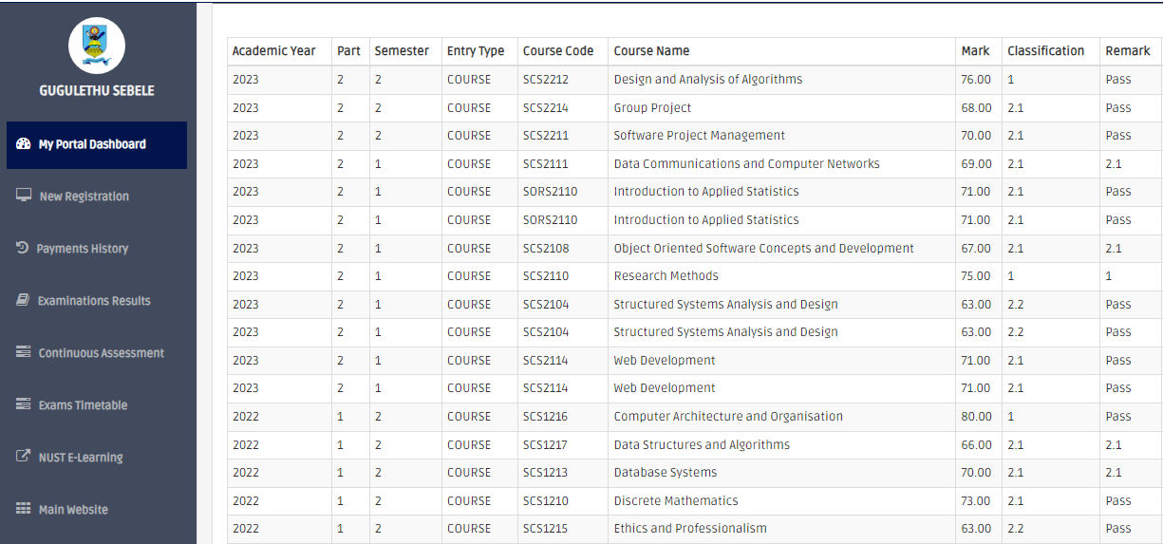

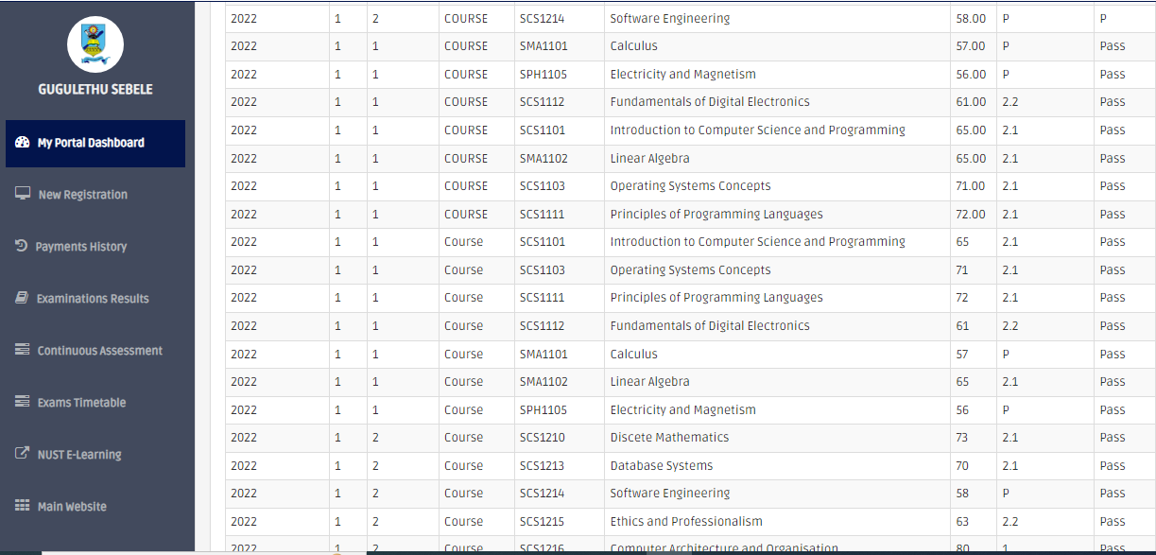

Above are my results from part 1.1 to part 2.2

**References:** Lecturer and industrial attachment coordinator: MRS NAMATIRAI MARABADA Email: [namatirai.marabada@nust.ac.zw](mailto:namatirai.marabada@nust.ac.zw)

COMPUTER SCIENCE DEPARTMENT

Cell: +263 775176782

